Open Mix Designs from the Materials Management Panel

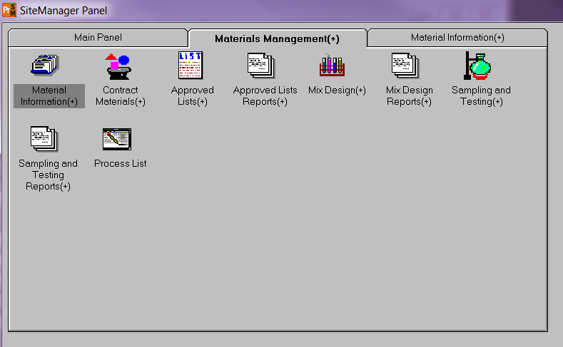

Open either the Superpave Mix Design or the PCC Mix Design.

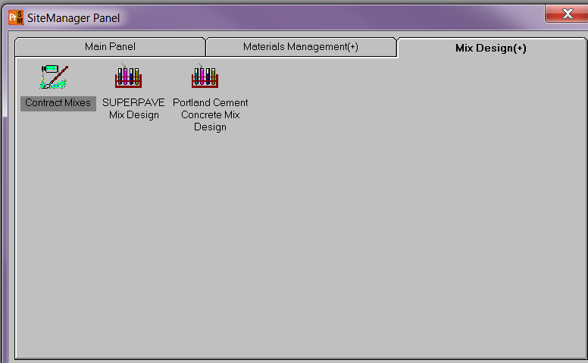

There are only 3 fields required to enter so that the Mix ID is available for samples.
- Enter the Mix ID number that is generated from LAPAVE.
- Enter or search for the material code of the final product (0501M00010 for Thin Asphalt Concrete, 0502M00010 for Asphalt Concrete or any of the 0901M materials for PCC Structural or Pavement)
- Enter or search for the Producer/Supplier you have approved to supply the final product.

If you want to enter a Termination Date for the Mix Design you may, but it is not required. If you terminate the Mix Design at a later date, come back to the Mix ID and enter the Termination Date so it is no longer available to be added to a sample ID.

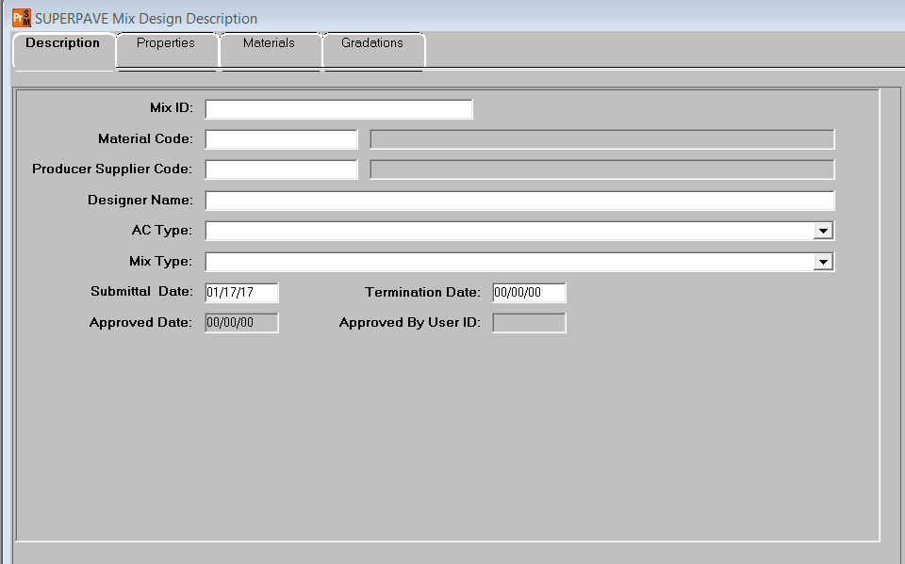

Click Save.

This is all that needs to be done to save a Mix Design ID number in SiteManager.

